2025-09-09 – Pong Code Issues
The existing pong code works, with some caveats:
- It is written in Verilog instead of VHDL
- It does not include the functionality of turning on the HDMI peripheral
1 is a relatively easy fix, the files can be translated into VHDL 1:1.
2 is not an easy fix. The only implementation I can find for turning on the HDMI peripheral involves setting up a Nios ii soft-core CPU and writing i2c drivers for it. It’s probably possible to copy over a lot of the functionality, but it doesn’t feel appropriate to include so much difficult/hidden away content in the workshop, and would make setup more complicated.
A workaround for this that I’ve found works is to power cycle the FPGA board, making it load its built-in program. The built-in program includes HDMI functionality that turns on the chip. So long as the HDMI cable isn’t unplugged and plugged back in (unplugging it disables the peripheral), the Pong program can be uploaded to the board & work.
Possible solutions:
- Port pared-down version of example program and Nios ii to our workshop
  - + it is an interesting bit of technology & explaining how the core can be hardware-reconfigurable for a variety of uses is a good application note
  - – lots of complexity added, increases the barrier to self-studying the provided code drastically
  - + I would enjoy learning more about this
- Find i2c IP to use in the program, then use that to configure the chip
  - + gives an opportunity to explain IP and how they can accelerate design
  - + closer to how it would be done in an actual production environment
  - – again, more difficult for students to get whole picture, could be a bit of a black-box
- Use workaround described above
  - + Easiest solution
  - - Finicky, needs more testing to see what problems could pop up
It looks like someone already has an i2c implementation in the project, will debug further to see why it isn’t waking up the monitor
There are some issues with pin assignments in the existing project, doing some testing to see if fixing those will get the i2c working.
Fixed! Just needed to update the two pin assignments reset_n to the following (note they are now cpu_reset_n:
Now pressing the CPU reset button will properly initialize HDMI and we don’t need the workaround.
2025-09-09 – Workshop pedagogy ideas
HDMI timing is too complicated & has too much prerequisite knowledge required to have participants complete it themselves. Likely best to provide the file to users and just have them include it in their project

Easier tasks to complete:
- Fill screen with one color
  - Requires setting up PLL clock VHDL to drive clock timing
    - Unless we move that to the HDMI timing, then just say it takes a default-speed clock? Might be worth not giving this because there’s no good way to see it working/get immediate feedback
  - Requires setting up process to send a specific color for X and Y position on screen
    - Easiest pattern is solid color, could have them make a pattern with some math
  - For anyone unfamiliar, good opportunity to explain/explore RGB color model & screen-space coordinates
  - Opportunity to demo good project structure
- Draw a rectangle with specific coordinates
  - More experience passing signals back and forth
  - Good exposure to components, inputs/outputs?
- Make that rectangle move
- Collision detection
- State machine (serve delay / in game)
- Text rendering for score
- Setup PLL for HDMI signal timing using Quartus IP
  - Gives participants an idea of how to use IP components, better picture of how production products might do it
  - Gives us an opportunity to explain FPGA IP components and how they fit into the ecosystem
  - Requires some knowledge of project structure and how to use components in architectures.
  - Need explanation of direct instantiation too?
- Clamp function for game logic
  - Introduces functions

2025-09-09 – Conversion to VHDL
Plan is probably to just create a new project following the introductory workshop instructions and start translating the Verilog into equivalent VHDL. This helps deal with some of the sketch pin assignments and will keep the setup as simple as possible for participants (create new project same as last time, import some files).
2025-09-10 – Conversion to VHDL cont.
Conversion on hdmi_top started, need to experiment and find out how the PLL works. I suspect the original Verilog version used an IP component, I’ll try doing the same and see if it matches up with the old version.
Steps for adding PLL IP component (for this specific project):
- Open the IP Catalogue using the Open IP Catalogue button (see below) or by pressing Alt+7.
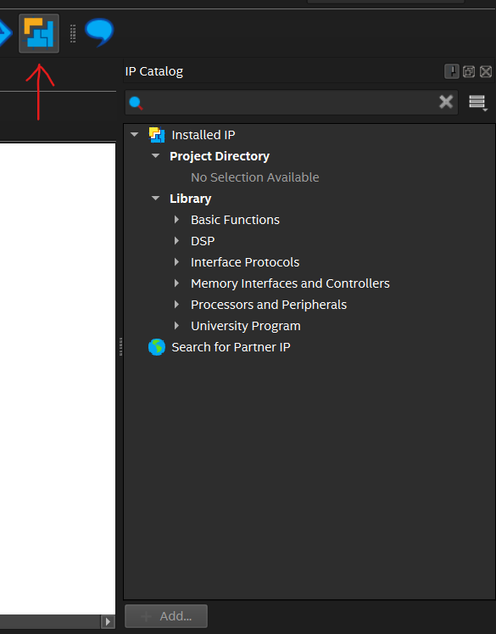
- Search the IP Catalogue for “PLL Intel FPGA IP” and select it from the list.
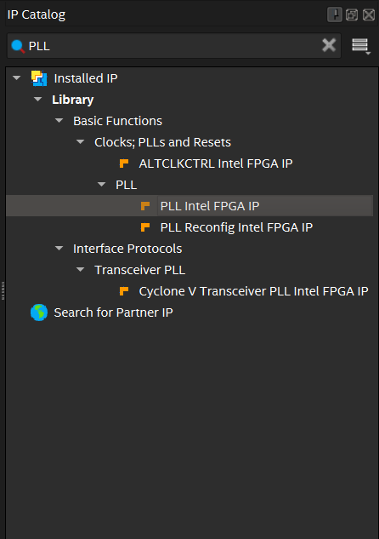
- In the popup, choose a name for the generate IP variation (here, we chose “pll_74mhz”) and select the VHDL radio button. Then, press OK.
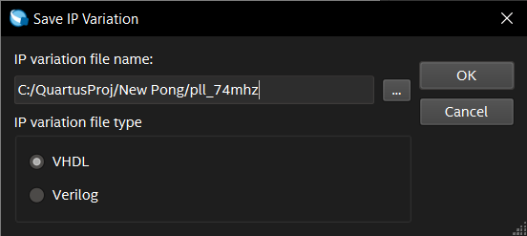
- Wait for the MegaWizard to load. This may take a couple seconds.
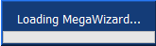
- In the MegaWizard, change the following parameters:
  - Reference Clock Frequency: 50.0MHz
  - Desired Frequency: 74.25MHz
  - Actual Frequency: 74.242424MHz (should be auto-selected after inputting desired frequency)
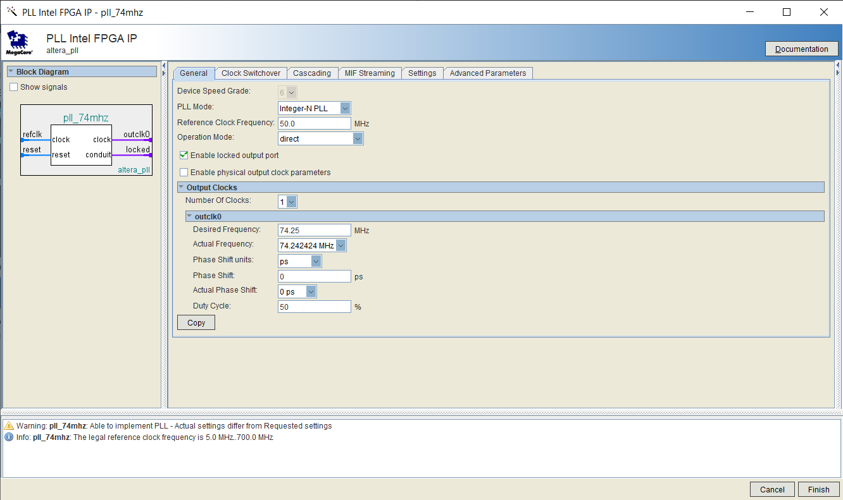
- Click finish. Await the “Generation Successful” message in the Generation window that appear.
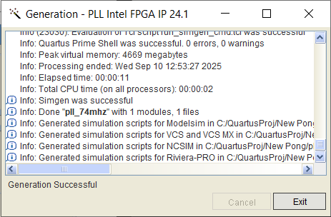
- If you receive a popup asking to add the generated IP variation file to the project, check the box naming your IP variation file (and optionally the checkbox to automatically do the same for all IP variations you generate in the future), and press Yes.
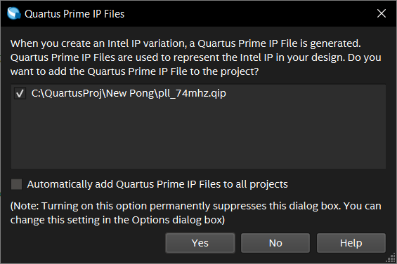
- The PLL IP variation is now available to use as a component in the project.

To see the generated design files, in the project navigator (on the left of the screen), select IP components in the dropdown. Then, right click on the IP component you wish you view. Select Locate Node > Locate in Design File to open the generated design file. You may also edit the IP component’s parameters by selecting Edit in Parameter Editor when you right click the component.
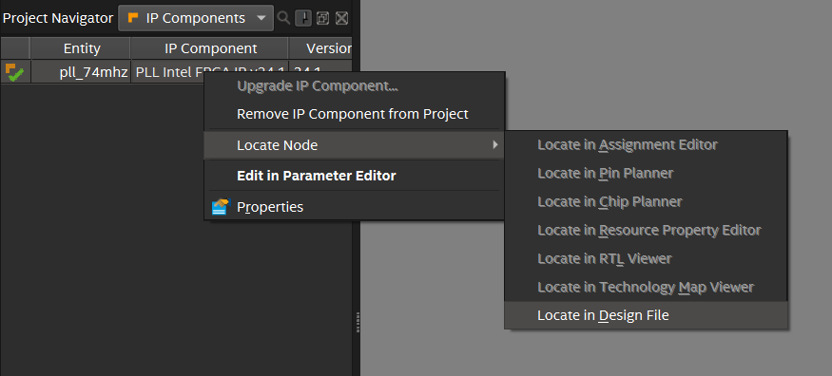
The entity declaration in the design files is useful for writing a component declaration in a structural architecture.
2025-09-11 – VHDL Coversion
Converting the top module, video timing module, and part of the rendering module went smoothly, but displaying didn’t work. After swapping some of the rewritten components for their originals, I figured out it was because the i2c setup component was necessary even if I tried to bandwagon off the built-in program’s setup/config. Adding the i2c component got the video to work, I tweaked some of the registers being written in the i2c component to get correct 24-bit RGB color working and got a test pattern to display. See the register map in the ADV7513 Programming Guide to get a better idea of how the video format is set up.
Bumped into an issue where some shortcut changed the top-level entity & I didn’t notice. Graphics stopped working & some 7-segment display LEDs lit up. Will probably see this issue crop up during the workshop so keep an eye out

